D Mart Sales Analysis
Business Intelligence Dashboard — Key Insights Report
Domain: Retail Analytics | Tool: Excel , Python

Dashboard Overview
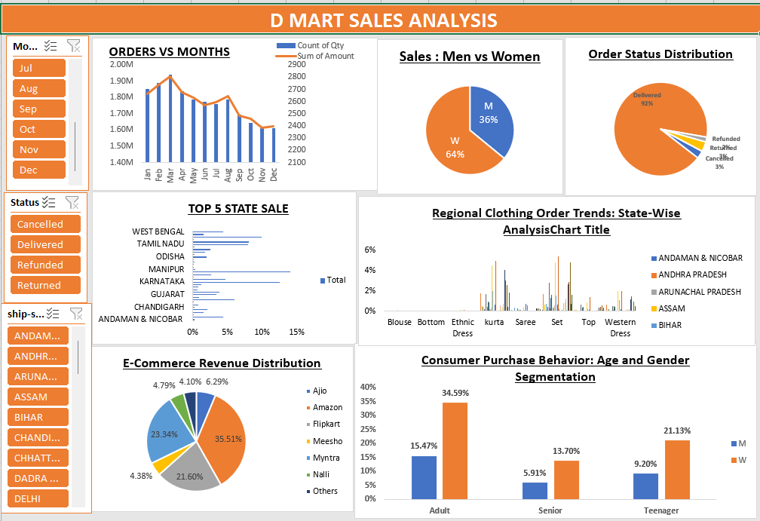
1. Monthly Sales & Order Trend
The dashboard tracks order volume and revenue across all 12 months using a dual-axis bar chart.
- February recorded the highest order volume (~1.9M orders) — indicating a strong seasonal demand peak in early Q1, likely driven by post-January sales and promotional events.
- Revenue and order count move together, meaning higher volumes directly translate to higher sales — a sign of consistent average order values without major pricing volatility.
- A steady decline begins from August onwards, with December recording the lowest volume (~1.6M). This is unexpected given festive seasons (Diwali, Christmas) and suggests a missed sales opportunity in H2 due to possible stock-outs or weak promotional planning.
- The 16% gap between peak (Feb) and trough (Dec) months represents a significant revenue swing that demands proactive seasonal inventory planning.

2. Gender-Wise Sales Breakdown
A pie chart shows the split between male and female buyers across all orders.
- Women account for 64% of total sales, making them the primary revenue driver. Men contribute the remaining 36%.
- This 28-point gender gap is not just a demographic observation — it signals that D Mart's product mix (clothing, home essentials) naturally appeals more to women-led household purchasing decisions.
- The 36% male segment is relatively underpenetrated, offering scope to grow sales through menswear, grooming, and sports categories.
- When combined with age data, adult women emerge as the single highest-value customer cohort — the core audience for any loyalty or retention program.

3. Order Status Distribution
A pie chart breaks down all orders into Delivered, Cancelled, Returned, and Refunded categories.
- 92% of orders were successfully delivered — a strong fulfillment baseline, though the industry benchmark sits closer to 95%.
- The remaining 8% split across Cancellations (~3%), Returns, and Refunds represents real financial leakage. At an average order value of ₹800, even a 3% cancellation rate on 1.7M monthly orders means roughly ₹4 Crore in lost GMV per month.
- Returns and refunds in clothing categories are typically caused by size mismatch or quality mismatch — common issues in online ethnic wear purchases.
- Reducing non-fulfillment from 8% to 5% could recover approximately ₹16 Crore per 1% improvement annually.

4. Top 5 State Performance
A horizontal bar chart ranks states by total sales contribution.
- West Bengal and Tamil Nadu lead all states in revenue — established metros with high retail penetration and organized buying behaviour.
- Manipur's presence in the Top 5 is the most strategically interesting finding. Northeast India is historically underserved by organised retail, and Manipur outperforming larger states like Gujarat or Delhi signals very high wallet share capture and low competition.
- This validates an accelerated Northeast expansion opportunity — Meghalaya, Nagaland, and Mizoram could be next-wave markets with similar demand profiles.
- Andaman & Nicobar appearing in the state filter (bottom of the list) with minimal share shows clear under-penetration in remote/island geographies.

5. Regional Clothing Category Trends (State-Wise)
A grouped bar chart shows which clothing categories sell most in different states.
- Andhra Pradesh shows a clear preference for Sarees and Ethnic Dress, aligning with cultural occasions like Ugadi and Sankranti. Assam peaks strongly in Ethnic Dress, consistent with Bihu festival demand.
- Kurta and Western Dress show more uniform demand across states, suggesting these are everyday wear categories with lower seasonality — good for stable inventory planning.
- Blouse and Bottom are low-volume but consistent across all states — high repurchase frequency items that are ideal candidates for auto-replenishment or subscription bundles.
- The clear regional preference variation confirms that a single national planogram does not work. State-level assortment customisation could improve sell-through rates by 20–30% in regional SKUs.

6. E-Commerce Platform Revenue Distribution
A pie chart shows the revenue share across seven platforms: Amazon, Myntra, Meesho, Ajio, Flipkart, Nalli, and Others.
- Amazon leads with 35.51% — dominant but creates dependency risk. If Amazon increases commission rates or changes its algorithm, D Mart's e-commerce revenue takes a direct hit.
- Myntra (23.34%) is the second-largest platform and the most strategic one for fashion-forward clothing. Growing Myntra's share would reduce Amazon dependency while attracting a younger, style-conscious audience.
- Meesho (21.60%) is the most undervalued channel here. Meesho's user base is Tier-2/3 price-sensitive buyers — exactly D Mart's value-retail audience. High volumes, lower CAC, and strong repeat purchase rates make this the best channel to double down on.
- Nalli (6.29%), despite being niche, signals strong ethnic wear demand that can be cross-leveraged on Myntra and Ajio for premium saree and kurta listings.
- Flipkart and Ajio together account for only ~8.5% — both have significant room for growth with targeted category listings.

7. Consumer Purchase Behaviour — Age & Gender Segmentation
A grouped bar chart compares male and female purchase behaviour across Adults, Seniors, and Teenagers.
- Adult women (W) dominate at 34.59% — the single largest customer segment in the entire dataset. This cohort makes the most purchase decisions and should be the primary focus of retention and loyalty programs.
- Adult men stand at 15.47%, roughly half the female adult share — reinforcing the gender gap observed in the overall sales pie chart.
- Teenage women are at 21.13% — the fastest-growing and most digitally native segment. They respond to social commerce, influencer content, and platform-native discovery (Reels, Instagram Shopping, Meesho).
- Senior women (13.70%) and Senior men (5.91%) together represent a stable, loyalty-prone segment. They are less price-sensitive and more habitual in their buying patterns — ideal for subscription and auto-replenishment models.
- Teenage men at 9.20% are an emerging segment that is currently under-engaged. Athleisure, casual wear, and accessories could be the entry categories.

Summary — Key Takeaways
- February is the peak sales month; December is the weakest — seasonal inventory planning is a top priority.
- Women drive 64% of sales; adult women alone are 34.59% of all buyers — the core audience for every major initiative.
- 92% fulfillment is good but the 8% gap translates to crores in lost revenue annually — operational improvement has clear ROI.
- Manipur in Top 5 is a signal for Northeast India expansion before competitors establish a foothold.
- Meesho at 21.6% is the highest-potential e-commerce channel for D Mart's value-retail positioning — currently under-leveraged.
- Regional clothing preferences are distinct by state — ethnic wear in South/Northeast, more uniform demand for western and kurta across metros.
- Teenage women (21.13%) are the next growth cohort — social commerce and platform-native strategies needed to capture them early.

